No. 2

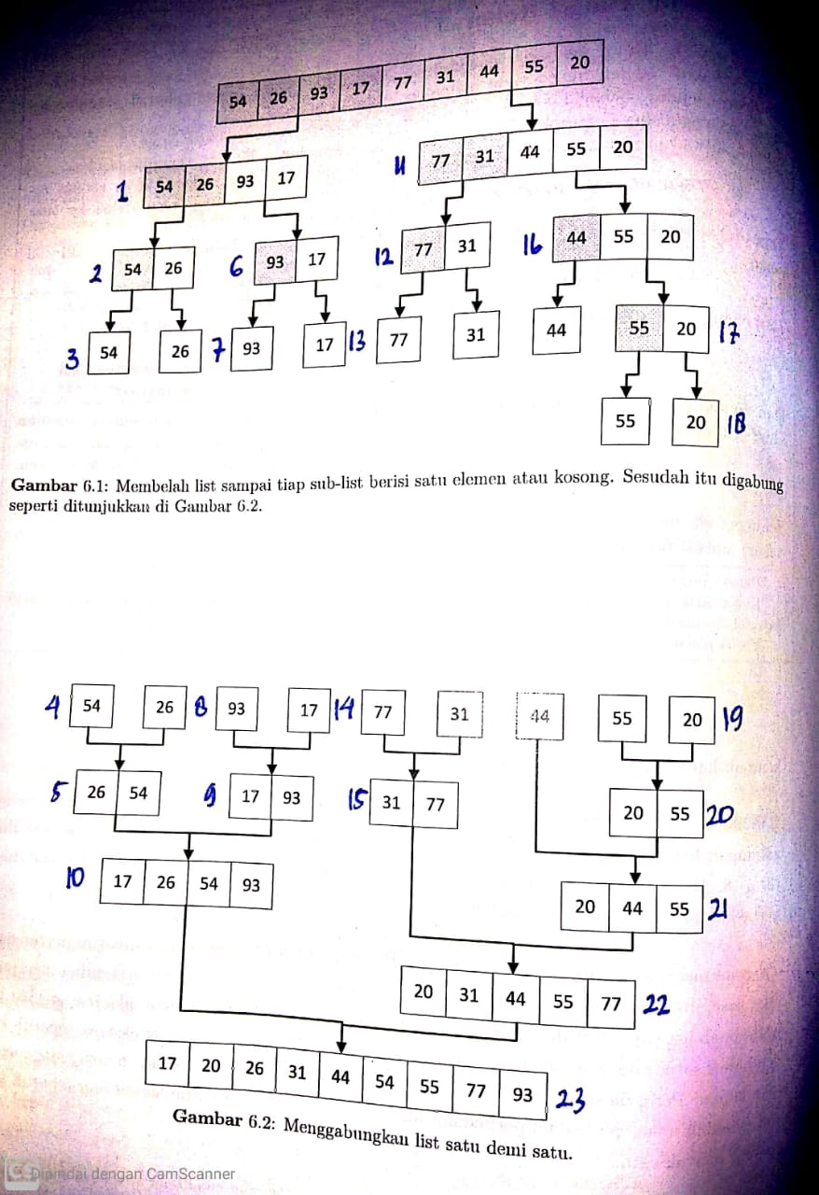

No. 4

1. Merge Sort

L= [80, 7, 24, 16, 43, 91, 35, 2, 19, 72]

|  |  |  |  |  |  |  |  |  |  |
| --- | --- | --- | --- | --- | --- | --- | --- | --- | --- |
| 80 | 7 | 24 | 16 | 43 | 91 | 35 | 2 | 19 | 72 |

Proses 1

   

Proses 2

  

Proses 3

 

Proses 4



1. Quick Sort

